COIT13230: Application Development Project

Term 2, 2026

Assessment 3 – Group Project Final

Student names:
Matthew Haydon – 12232615
Farhad Azim – 12284745
Ansh Patel – 12268984

Course Coordinator: Farzad Sanati
MatthewUNI/COIT13230-Application-Development-Project: Development of AI-Based Smart Meal Planner

Contents
Introduction 4
Project Progress and Tracking 5
Implemented User Stories, Interfaces, Features and Business Logic 6
User Profile and Mobile Interface — Matthew 6
AI Meal Plan and Recipe Generation — Farhad 7
Nutrition Analysis, Grocery List and Data Storage — Ansh 7
Implementation Details 8
User Profile and Mobile Interface — Matthew 8
AI Meal Plan and Recipe Generation — Farhad 9
Nutrition Analysis, Grocery List and Data Storage — Ansh 9
Integration and Testing 10
Integration Testing 10
Functional/Test Results 10
Evaluation Against Original Requirements and Design 11
Requirements Fulfilment 11
Functional Requirements 11
Non-Functional Requirements 12
Summary of Requirements Fulfilment 13
Project Objectives and Scope 14
System Architecture and UML Comparison 14
User Interface Design Comparison 14
Use Case and Context Diagrams 14
Database Design and ERD 14
Client–Server Communication 14
Artefact Refinement 15
Matthew - System Architecture Comparison 15
All members - Updated UML class diagrams 16
Ansh - Updated ERD vs Original 16
Farhad - Client-Server Communication diagram vs Original 16
Errors, Problems and Resolutions 17
Nutrition Calculation and Ingredient Identification 17
Cooking Oil Ingredient Matching 19
Grocery List State Persistence 19
Application Timeout During Nutrition Analysis 20
Divergence from Original Requirements and Design 21
Matthew 21
Bottom Navigation and Grocery List Access 21
Meal Plan and Recipe Interface Structure 21
Home Screen Meal Inclusion Controls 21
Farhad 22
Ansh 22
Collective 22
GitHub Repository and Version Control 23
Ethical and Professional Considerations 24
Conclusion 24

Introduction
The AI-Based Smart Meal Planner is an Android application developed to provide personalised meal planning based on information supplied by the user, including health and weight goals, dietary requirements, food preferences and available ingredients. The application incorporates Generative AI to support the generation of personalised meal plans and recipes, alongside supporting functionality for nutritional information, grocery list generation and application data storage.
Following the requirements analysis and software design completed during the earlier stages of the project, development progressed into the implementation, integration and testing of the proposed Android prototype. The project was initially divided into three primary areas of responsibility: User Profile and Mobile Interface, AI Meal Plan and Recipe Generation, and Nutrition Analysis, Grocery List and Data Storage. As implementation progressed, these responsibilities provided the foundation for development while team members also contributed across component boundaries where changes, integration or troubleshooting were required.
This report presents the current implementation of the AI-Based Smart Meal Planner and documents the user stories, interfaces, features and business logic implemented during the development period. It also outlines the implementation of the major software components, integration and testing undertaken, errors and problems encountered during development, and changes made from the original requirements and design. Project progress and individual contributions are supported through implementation evidence, testing results and the version history maintained within the project's shared GitHub repository.

Project Progress and Tracking
The project moved through the planning and design phases to be developed into a working Android prototype. We divided the major application components among the team members based on their responsibilities. These included the UI and user profile, AI-based meal-plan and recipe generation, nutrition analysis, grocery-list functionality and local data storage. Each team member worked on their allocated components, and these features were progressively integrated into the shared application.
Throughout the development of the project, the different components were connected to allow data to flow between features. AI-based meal plans were integrated with the nutrition analysis and grocery-list functions, while user-profile information was used to support personalised meal planning and available-ingredient management. Room database functionality was also implemented to provide local persistence for important application data such as saved meal plans and grocery-list data.
During development and integration, testing and debugging were carried out. This revealed issues such as inaccurate nutrition calculations, AFCD ingredient-matching problems, persistence of grocery-list purchase states when restoring saved meal plans, and grocery-list visibility. As the application continued to develop, the identified issues were debugged, fixed and retested.
GitHub was used throughout development for version control and team collaboration. As work was completed, team members committed and pushed their feature implementations, fixes and documentation updates to the main branch. This provided a history of the project's development and allowed the individual components to be progressively integrated into the main branch. Currently, the major features of the application have been integrated, with the remaining work focused on final testing, documentation and preparation for the final demonstration.

Implemented User Stories, Interfaces, Features and Business Logic

User Profile and Mobile Interface — Matthew
The User Profile and Mobile Interface functionality was implemented to allow users to enter and manage the information required for personalised meal planning and to provide access to the application's major features. The implemented profile allows users to select a health and weight goal, enter their current and target weight, specify dietary requirements and food preferences, and manage ingredients currently available to them. This information can then be accessed by other application components when generating personalised meal plans and recipes, consistent with the original User Profile requirements.
The available ingredients functionality allows ingredients to be added to and removed from the user's current ingredient list. The interface provides feedback when no ingredients have been entered and dynamically updates the displayed list as ingredients are added or removed. This implements the original requirement for users to add, view and remove available ingredients while keeping this information available for meal and recipe generation.
The Mobile Interface was implemented using separate screens for the application's primary functionality, with bottom navigation providing access between Home, Profile, Meal Plan and Grocery List functionality. During implementation, the interface was also expanded to support the presentation of generated meal plans and recipes. Generated weekly meal plans are organised by day, with breakfast, lunch and dinner displayed for each day. Recipe information can be expanded to display nutritional information, ingredients and preparation instructions. These interfaces allow the output produced by other application components to be presented within the Android application rather than operating as isolated backend functionality.
The Home interface also handles the state where a meal plan has not yet been generated by displaying appropriate feedback rather than empty meal and nutrition information. Once a meal plan is available, the interface can present the generated meal and nutrition information and provide access to related application functionality.

AI Meal Plan and Recipe Generation — Farhad

Nutrition Analysis, Grocery List and Data Storage — Ansh
The developed application was designed to perform nutrition analysis for generated meals, relying on nutritional information provided by the Australian Food Composition Database (AFCD). Generated ingredients are processed and matched with the local AFCD dataset to calculate protein, carbohydrate, fat and calorie values based on the different ingredients. These outputs are presented as part of the generated meal and day-wise nutritional data.
The app creates a grocery list based on the user's active meal plan while factoring in ingredients already available to the user. Grocery items can be marked as purchased using checkboxes, and their purchased states are saved in the Room database for persistence when closing and reopening the application.
Room/SQLite is used for local data storage to persist application data. This includes storage for saved meal plans and grocery-list contents, keeping important application data available the next time the application runs.

Implementation Details

User Profile and Mobile Interface — Matthew
The User Profile and Mobile Interface were implemented in Kotlin using Android fragments, XML layouts and supporting model and management classes. The implementation separates the user-facing interface from the profile data used by the rest of the application, allowing profile information to be accessed by meal-plan and recipe functionality rather than being contained only within the Profile screen.
The User Profile implementation stores the user's selected goal type, current and target weight, dietary requirements, food preferences and available ingredients. Interface controls collect and update these values, while the available-ingredient functionality dynamically adds and removes ingredients from the user's current list. The Android interface was structured using fragments for the application's primary screens and a common navigation structure to move between them. Additional reusable XML layouts were created during implementation to support dynamically generated meal-plan and recipe information
The interface implementation also includes state handling and user feedback. For example, the Home screen distinguishes between having a generated meal plan and having no meal plan available, while the Profile interface updates the available-ingredient display as ingredients are added or removed. These behaviours were implemented to provide clear feedback and avoid displaying incomplete or misleading information to the user, consistent with the original interface requirement to provide feedback when information is missing or invalid.

AI Meal Plan and Recipe Generation — Farhad

Nutrition Analysis, Grocery List and Data Storage — Ansh
The nutrition analysis module was developed to handle ingredient lists from meal plans generated through the application and link them to nutritional records obtained from the Australian Food Composition Database (AFCD). The matching step handles the generated ingredient descriptions and quantities, then uses the matched nutritional values to calculate protein, carbohydrates and fat. Calories are calculated based on the processed macronutrients using: Protein × 4 + Carbohydrates × 4 + Fat × 9.
The generated meal plan and the user's available ingredients are used for the grocery-list functionality. The grocery list processes the meal-plan ingredients and generates the necessary grocery items. Users can mark items in the grocery list as purchased, and that state is saved in the local database of the app.
Room was used as the local persistence technology for application data. Grocery items are modelled as database entities and accessed through DAO operations including inserting, retrieving, updating and deleting records. This enables grocery-list information, including the purchase status, to be retained across application sessions. Meal-plan data is also stored locally for future restoration of generated plans.
The nutrition, grocery-list and database components are integrated with other application components through a shared MealPlannerViewModel, which allows generated meal-plan data to be processed across the nutrition and grocery-list features.

Integration and Testing

Integration Testing
Integration testing tested whether the main components built by different team members worked properly together as a full Android application. After an AI-generated meal plan was created, it was tested with the nutrition analysis functionality to determine whether the generated ingredients could be processed and matched with data available from the Australian Food Composition Database (AFCD). The generated meal plan was also integrated with the grocery-list feature, since ingredients from active meal plans are transformed into grocery items while considering food that the user may already have available in their profile.
The ability of grocery items and their purchased status to persist between app sessions was tested through the integration of the grocery-list feature with the Room database. In addition, restoring previously saved meal plans was tested with the grocery-list functionality to check that restoring a plan did not negatively affect the already saved purchased state of grocery items. The grocery list was also verified after further integration improvements to make sure saved items were still being shown and previously checked items had their state restored.
The shared MealPlannerViewModel allows the meal-plan, nutrition and grocery-list functionality to communicate with each other. We performed testing through the Android emulator using automated instrumented tests and end-to-end manual testing. This helped validate the data exchange between integrated components and identify bugs that occurred when multiple features were used together.

Functional/Test Results
The integrated Android application was tested to check the nutrition analysis, grocery-list, data persistence and meal-plan functionality. Automated instrumented testing was conducted using the Android emulator, where all seven instrumented tests completed without errors. We also performed manual testing for grocery-list persistence. Items were checked off in the grocery list, the application was closed and reopened, and the same saved meal plan was restored. This test was repeated several times, and after every restart the previously purchased items remained checked. Nutrition testing was also performed following improvements to AFCD ingredient matching, including testing the handling of cooking oil.

Evaluation Against Original Requirements and Design

Requirements Fulfilment

Functional Requirements
Original Requirement | Status | Implementation / Evaluation
Enter and update information for personalised meal planning | Met | Users can enter and update profile information through the Profile interface.
Set health and weight goals | Met | Users can select weight loss, maintenance or gain goals and enter current and target weights.
Enter dietary requirements and restrictions | Met | Dietary requirements can be entered and stored within the user profile.
Enter available ingredients | Met | Users can add, view and remove available ingredients.
Generate personalised weekly meal plans | Met | Gemini is integrated to generate seven-day meal plans using user profile information.
Generate recipes | Met | Generated meals include recipes with ingredients and preparation instructions.
Suggest alternative ingredients | Not Met | Does not provide alternative ingredient suggestions. However, users can specify dietary preferences and restrictions, which are considered during AI meal generation.
Provide calorie and nutritional information | Met | The Nutrition Analysis Engine uses AFCD data to calculate calories and nutritional values for generated meals.
Provide macronutrient and micronutrient information | Partially Met | Protein, carbohydrates and fat are calculated, but micronutrient analysis was not fully implemented.
Generate grocery lists | Met | Grocery lists are generated from meal plans while considering ingredients already available to the user.
Categorise grocery list items | Met | The Grocery List Generator organises grocery items into relevant categories. Users can also filter the list to display only items required for the selected day.
View meal plans, recipes, nutritional information and grocery lists | Met | The Android interface provides screens for accessing the generated information.

Non-Functional Requirements
Original Requirement | Status | Implementation / Evaluation
Respond to user interactions within a reasonable time | Met | Performance issues were identified during nutrition analysis. Background processing and on-demand calculations improved responsiveness.
Handle and store user information securely | To Verify | User profiles are stored locally using SharedPreferences, while Room provides persistence for other application data. The security of storage and API communication requires further verification.
Handle errors or unavailable external services without unexpected crashes | To Verify | The application includes error-handling mechanisms, but complete testing of network failures and unavailable AI services has not been documented.
Generated meals follow dietary requirements and restrictions | Met | Dietary requirements are provided to the AI generation process which tailors the meals.
Provide a simple and consistent interface | Met | The application uses a consistent navigation structure, reusable interface components and feedback for missing information.
Operate on compatible Android devices | Met | The application was developed using Android Studio and successfully tested on an Android emulator and a physical Android device, where it was also used for a live demonstration.
Store and retrieve user information, meal plans, recipes and grocery lists accurately | Met | User profile information is stored using SharedPreferences, while saved meal plans and grocery-list information are stored using Room (SQLite). Testing confirmed that grocery-list purchase states persist across application restarts and that saved meal plans can be restored.

Summary of Requirements Fulfilment
The final implementation of the AI-Based Smart Meal Planner meets 10 of the 12 original high-level functional requirements, with one partially met and one not met. The main application functionality, including user profile management, personalised meal and recipe generation, nutritional analysis, grocery-list generation and the mobile interface, has been implemented and integrated.
The remaining functional limitations relate to ingredient substitution and micronutrient analysis. Although dietary preferences are considered during meal generation, the application does not currently provide explicit alternative ingredient suggestions. Additionally, nutritional analysis focuses on calories and macronutrients rather than the full range of micronutrients originally proposed.
Of the seven non-functional requirements, five are currently assessed as met, while two require further verification. Testing and integration improvements addressed application responsiveness and data persistence, and the application has been tested on both an Android emulator and a physical device. Further verification is required for the security of user information and the handling of unavailable external services.

Project Objectives and Scope

System Architecture, UML and Design Artefact Refinement

Matthew - System Architecture
The original system architecture established the main components of the AI-Based Smart Meal Planner and their interactions with the mobile interface, data storage, nutrition dataset and external Generative AI API. During implementation, this architecture was refined to reflect the actual structure of the Android application while retaining the core components identified in the proposal.
The updated architecture introduces the MealPlannerViewModel as the central component responsible for coordinating interactions between the mobile interface and application functionality, including meal plan generation, recipe generation, nutrition analysis and grocery-list generation. The data storage design was also refined to distinguish between SharedPreferences, which stores user profile information, and Room (SQLite), which manages saved meal plans and grocery-list information.
The external services and data sources were also clarified. The Gemini API is used for AI-based meal and recipe generation, while the Australian Food Composition Database (AFCD) is accessed through a local JSON dataset for nutritional calculations. Overall, these refinements maintain the original system design while providing a more accurate representation of the implemented application and the relationships between its components.
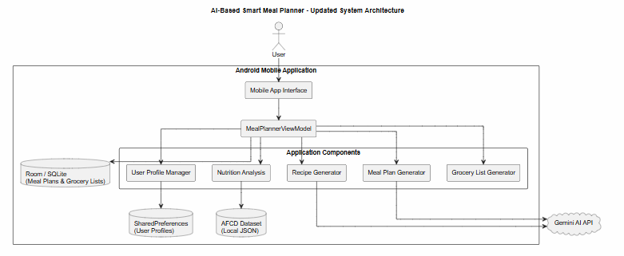

All members - UML Class Diagrams

User Profile UML Class Diagram
The original User Profile UML class diagram represented health goals, dietary requirements, food preferences and available ingredients as separate classes associated with UserProfile. During implementation, these were combined into attributes within the UserProfile data class, simplifying the structure while retaining the required profile information. The updated diagram also includes UserProfileManager, which manages and persists user profile information using SharedPreferences, and ProfileFragment, which provides the interface for users to enter and update their details. These refinements reduced unnecessary class relationships and aligned the design with the final Kotlin implementation without changing the intended functionality of the User Profile component.
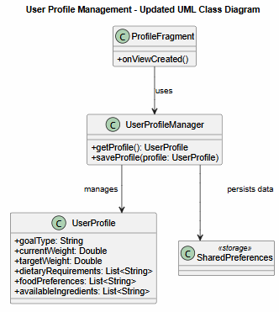

Database Design and ERD
Compare the original Entity Relationship Diagram (ERD) and proposed data storage approach against the implemented database. Evaluate whether the planned entities, attributes and relationships were implemented, and explain any changes to the database structure or persistence approach.

Client–Server Communication
Compare the proposed client–server communication design against the implemented Gemini API integration. Evaluate how requests are constructed and sent, how responses are processed, and how the application handles API errors or invalid responses.

Errors, Problems and Resolutions

Nutrition Calculation and Ingredient Identification
During manual testing, some meals produced unrealistic macronutrient values, including excessively high fat values. Investigation found that some generated ingredient quantities and units were not being interpreted correctly by the nutrition calculation logic. In particular, quantities written with the unit directly attached to the value, such as 15ml olive oil, were not always recognised correctly and could fall back to an inappropriate default quantity. The quantity-handling logic was revised to improve recognition of grams, kilograms, millilitres and other supported quantities, including values where there was no space between the number and unit. Generated meal-plan prompts were also updated to request consistent quantities in grams for solid ingredients and millilitres for liquids. These changes improved the reliability of quantity-based nutrition calculations.
Testing also identified inconsistencies between the calculated macronutrients and displayed calorie totals. In some generated meals, the calorie value remained relatively low despite significantly higher protein, carbohydrate and fat values. The calorie calculation was revised so that the final value is calculated from the processed macronutrients using the standard energy conversion values of Protein × 4 + Carbohydrates × 4 + Fat × 9. Subsequent testing confirmed that calorie totals were consistent with the calculated macronutrient values.
Ingredient identification against the AFCD dataset also presented problems because the terminology generated by the AI did not always correspond directly with terminology used by the AFCD dataset. For example, "ground beef" was not initially recognised as equivalent to "beef mince", while "whole wheat bread" needed to be interpreted using the AFCD terminology "wholemeal". 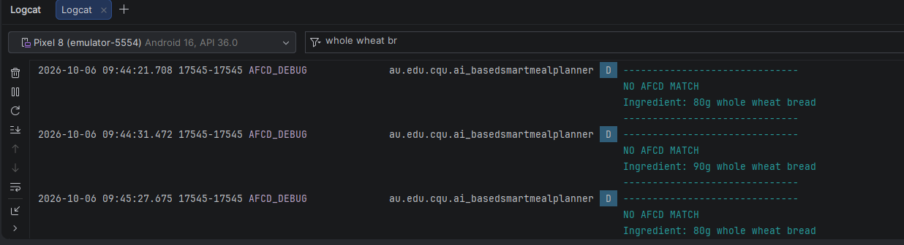

Ingredient terminology normalisation and aliases were therefore added to improve compatibility between generated recipes and AFCD records. A fallback mapping was also introduced for unsupported terminology such as ground turkey where an exact corresponding record was unavailable in the available dataset.
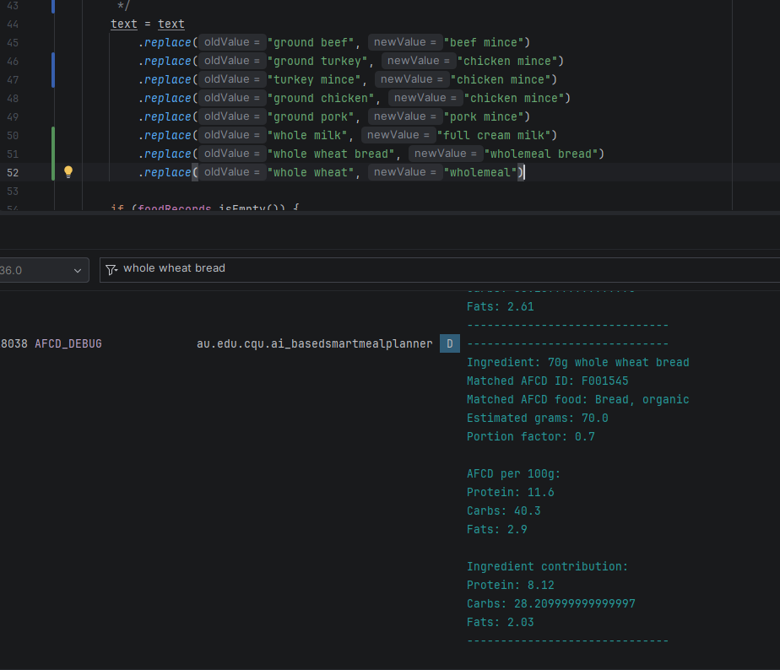
Further testing identified cases where an ingredient could be matched to a technically related but inappropriate AFCD record. For example, beef mince could be matched to a composite food containing beef mince rather than an appropriate standalone record, while an ingredient such as avocado could potentially match avocado oil. The matching logic was refined to consider ingredient terminology more carefully and to prevent transformed food records such as oils, juices, powders and flours from being selected when the generated ingredient did not specify that form. These changes reduced incorrect AFCD matches while retaining valid matches such as "olive oil" and "avocado oil".

Cooking Oil Ingredient Matching
Further manual testing identified problems with the matching and quantity processing of cooking oils. Meals containing cooking oil could initially produce extremely low, zero or unrealistic fat values when the ingredient was matched incorrectly or its quantity was not interpreted correctly. The descriptive term "cooking" was found to interfere with identifying an appropriate oil record and was therefore treated as a non-essential descriptor during matching.
Additional testing identified that liquid oil quantities such as "15ml olive oil" were not being recognised correctly when the number and ml unit were written together. The millilitre parsing logic was revised so that both "15ml" and "15 ml" could be processed correctly. The AFCD matching logic was also refined so that ingredients explicitly identified as oils could match appropriate AFCD oil records while preventing ordinary ingredients from incorrectly matching their oil equivalents. Instrumented and manual testing was then used to verify the revised matching and quantity-handling behaviour.

Grocery List State Persistence
Another issue identified during manual testing involved the purchased state of grocery-list items. Purchased items could appear unchecked after closing and reopening the application and restoring a saved meal plan. Investigation found that restoring the meal plan regenerated the grocery list, which could replace the purchased state loaded from Room. The restore logic was changed to avoid unnecessarily regenerating the grocery list when restoring a saved plan. The application was then manually tested multiple times by checking grocery items, closing and reopening the application, and restoring the same saved meal plan. The purchased items remained checked across the repeated tests, and all seven instrumented tests passed.

Application Timeout During Nutrition Analysis
During integration testing, the application experienced periods of unresponsiveness and Android timeout warnings, particularly when accessing the Recipes screen. Investigation identified that the AFCD nutrition analysis was performing intensive ingredient matching on the main UI thread. The Recipes screen was also calculating nutrition information for every generated recipe when the screen was loaded, resulting in high CPU usage and preventing the interface from responding normally.
To resolve this issue, the AFCD nutrition calculations were moved off the main UI thread using background coroutine processing. The Recipes screen was also changed so that nutrition information is calculated only when the user expands an individual recipe, rather than calculating nutrition for every recipe at once. This significantly reduced unnecessary processing when loading the Recipes screen and improved application responsiveness while retaining the required nutrition analysis functionality.

Divergence from Original Requirements and Design

Matthew
During implementation, several changes were made to the original interface and navigation designs as the application progressed from static designs into a functional Android prototype. These changes were made where testing and integration identified more practical ways of presenting or accessing application functionality.

Bottom Navigation and Grocery List Access
The original interface design used four primary bottom-navigation options: Home, Meal Plan, Recipes and Profile. The Grocery List was instead accessed through other areas of the application. During implementation, I changed the bottom navigation to include a dedicated Grocery List option. As the Grocery List is one of the application's primary components, direct access through the main navigation was considered more appropriate than requiring users to access it indirectly. This resulted in the implemented application using five primary navigation options rather than the four shown in the original interface design.

Meal Plan and Recipe Interface Structure
The original interface designs provided a high-level structure for displaying generated meal plans and recipes. During implementation and integration, I expanded these designs by creating additional reusable XML layouts for presenting the generated information in a more structured format.
I created a daily meal layout that groups breakfast, lunch and dinner under each day of the generated meal plan. I also created an expandable recipe layout that allows each meal's recipe information to be displayed when required, including its calories, macronutrients, ingredients and cooking instructions. item_day_meals item_recipe_dropdown A reusable card background was also created to provide consistent visual separation and styling for these dynamically displayed items. day_card_background

Home Screen Meal Inclusion Controls
A further change was made to the Home screen to improve the accuracy of the daily nutrition summary. The original interface design displayed the user's generated breakfast, lunch and dinner but did not provide a way to account for meals that the user may not consume. During implementation, I added Include/Exclude controls to each meal displayed on the Home screen. This allows a user to temporarily exclude a planned meal, such as when eating out for lunch, without removing or modifying the meal within the generated meal plan. When a meal is excluded, the daily calorie and macronutrient totals displayed on the Home screen are recalculated using only the remaining included meals. The meal remains visible and can be included again at any time. This functionality was not included in the original interface design but was added during implementation to make the daily nutrition information more representative of the meals the user intends to consume.

Farhad

Ansh
During implementation of the Nutrition Analysis component, the Australian Food Composition Database (AFCD) was selected as the public nutrition dataset identified in the original design. The final version of the prototype focuses on calculating and displaying calories and macronutrients, including protein, carbohydrates and fat. The original specification also included micronutrient information; however, micronutrient analysis was not fully implemented because development prioritised the integration and testing of the core nutrition functionality within the available timeframe.
The original design also proposed categorising grocery-list items into groups such as produce, pantry and protein. In the final prototype, grocery items are generated from the meal plan and displayed as a single list rather than being divided into these categories. Reliable grocery-list generation was prioritised, along with considering the user's available ingredients and using Room to persist the purchased state of grocery items. Therefore, grocery categorisation represents a divergence from the original proposal.

Collective

GitHub Repository and Version Control
GitHub was used throughout the development of the AI-Based Smart Meal Planner as the team's shared version control and source code management platform. The repository contains the Android application source code and provides a history of changes made throughout the implementation, integration and testing stages of the project. GitHub was originally identified as the project's version control and team collaboration platform. Group Project Proposal
Version control became particularly important as multiple team members developed separate components that were progressively integrated into the same Android project. In some instances, changes introduced conflicts or dependencies that had not been identified before integration. Maintaining a version history allowed the project to be reverted to a previous working version when required, reducing the risk of losing functional code while integration problems were resolved.
GitHub also assisted with reviewing changes before they were incorporated into the shared project. When changes were pulled or merged, the differences between versions could be reviewed to identify files and code that would be added, modified or replaced. This was particularly useful when integrating components developed by different team members, as unexpected changes or conflicts could be identified before they affected the working version of the application.
Team members regularly committed and pushed their development work to the shared repository, creating a traceable history of the project's development. The commit history therefore provides evidence of individual contributions while also documenting how the application changed throughout implementation, troubleshooting and integration.
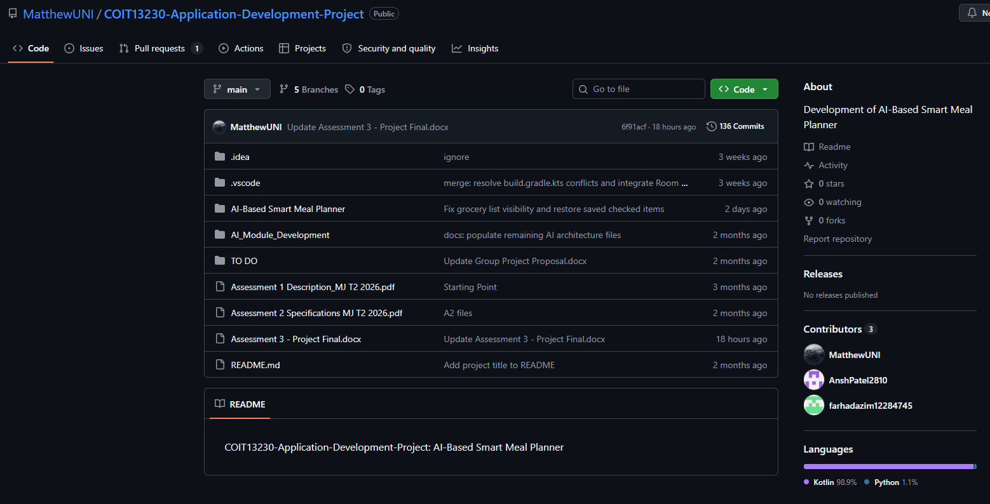

Ethical and Professional Considerations
The AI-Based Smart Meal Planner was developed to assist users with personalised meal planning; however, ethical and professional considerations must be taken into account due to the application's use of Generative AI and nutritional information. Although the application uses the Australian Food Composition Database (AFCD) to calculate nutritional values, the accuracy of these calculations depends on the ingredients generated, their quantities and how successfully they are matched to the dataset. As identified during testing, incorrect ingredient matching or quantity interpretation can result in inaccurate nutritional information.
Generative AI can also produce incorrect or unsuitable meal recommendations, particularly where users have specific dietary requirements or restrictions. Therefore, users should be advised to review generated recipes and verify ingredients before preparing meals, especially when managing allergies or other dietary restrictions. The application should also make clear that nutritional values are estimates and may not accurately represent the final prepared meal. The application should also include a disclaimer explaining that it is intended as a meal-planning aid rather than a substitute for professional dietary or medical advice. Users should be encouraged to consult a qualified healthcare professional or accredited practising dietitian when making decisions involving specific nutritional or health requirements.
The application also collects personal information, including weight goals, dietary requirements and food preferences. This information should be handled responsibly, with appropriate consideration given to user privacy, secure storage and the protection of information transmitted to external AI services.

Conclusion

